**DATA ANALYSIS**

**TOPIC: Student Depression**

Q1. Importing the Pandas file



Q2. Reads a CSV file of Student Depression

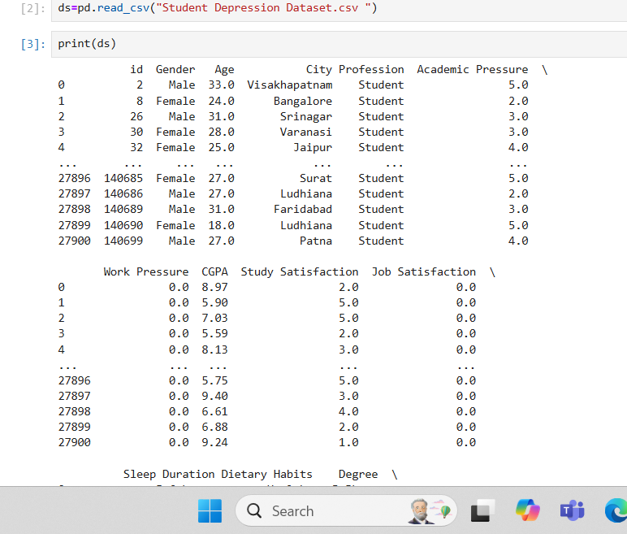

Q3. Display the top entries of data

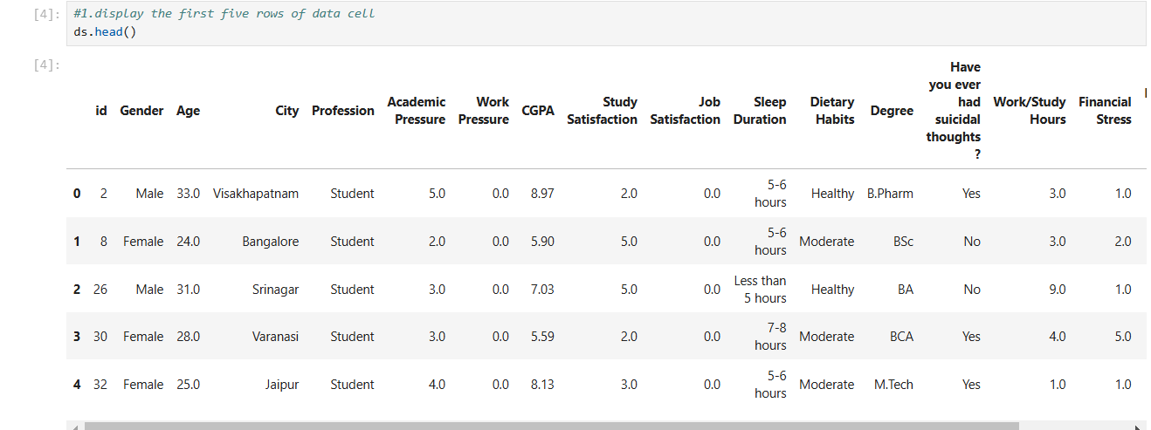

Q4. Display the Last entries of data

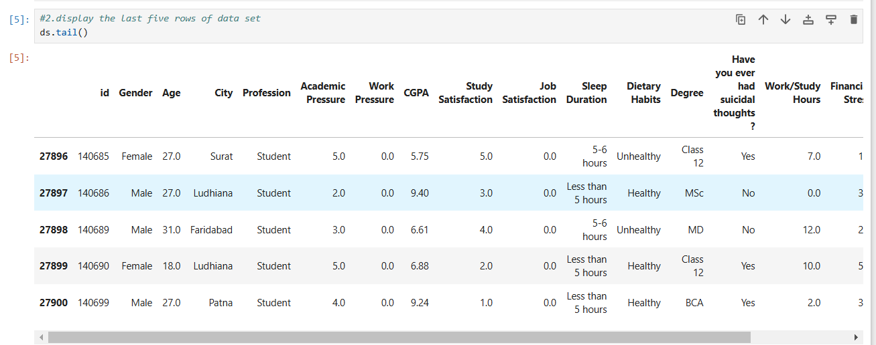

Q5. Count the Number of Rows and Columns.

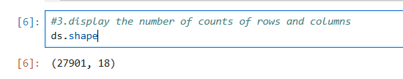

Q6. Which pandas function summarizes data types, non-null counts, and memory usage?

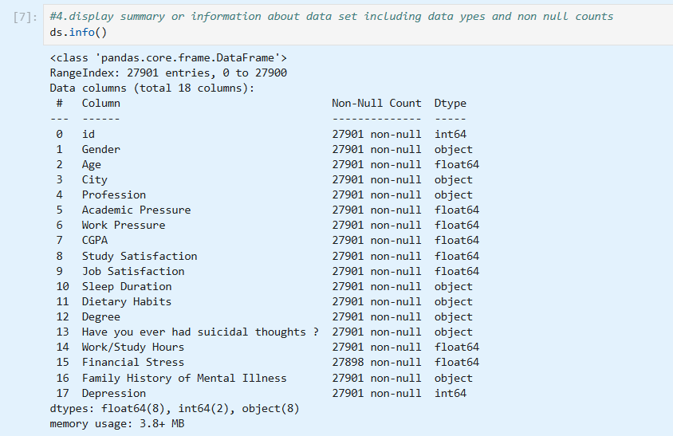

Q7. Which pandas function gives statistical summaries of numerical data?

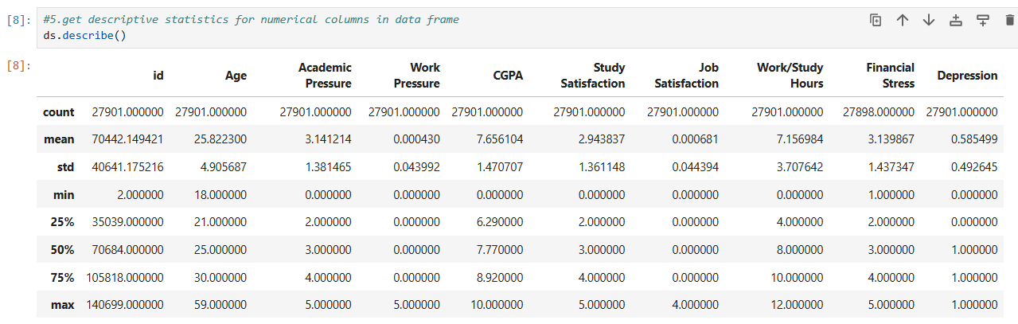

Q8. How to access the "Age" column in a pandas DataFrame?

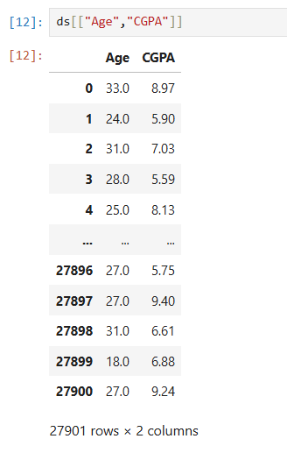

Q9. Accessing Multiple columns

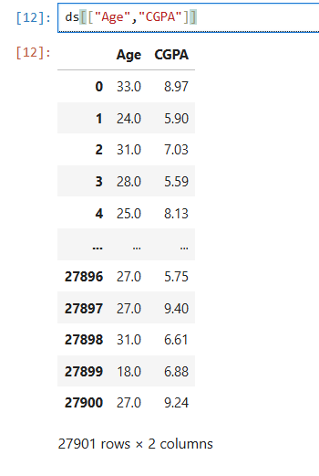

Q10. How to access the first row of a pandas DataFrame?

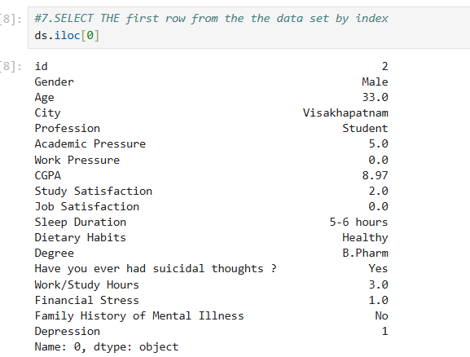

Q11. How to access the row with index 0 in a pandas DataFrame?

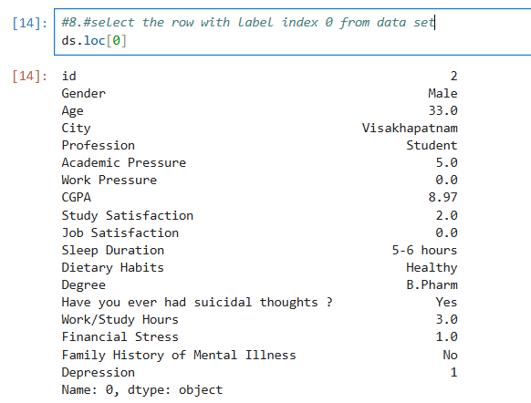

Q12. How to extract a subset of rows and columns

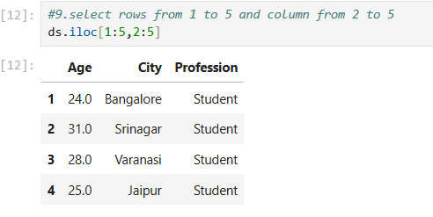

Q13. filter the data set for rows where age is greater than 30

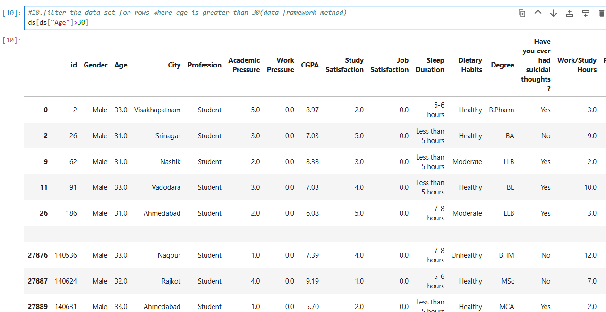

Q14. Use the query method to filter rows whether age is greater than 30

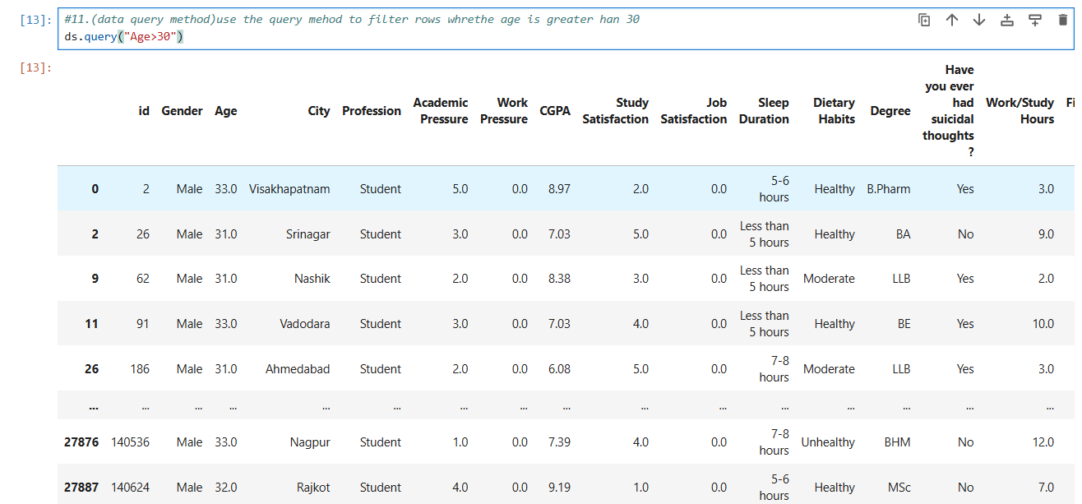

Q15. check if there are any missing values in data frame

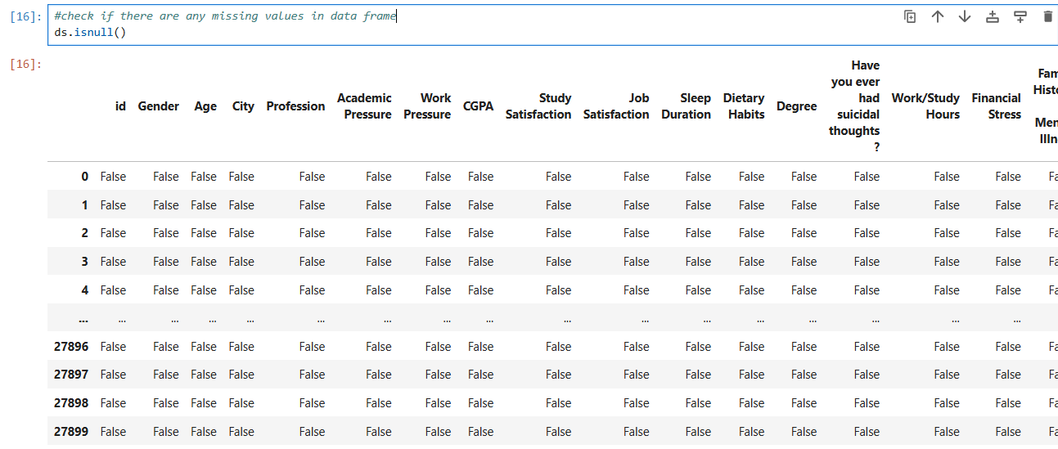

Q16. Count the number of missing values in the dataset

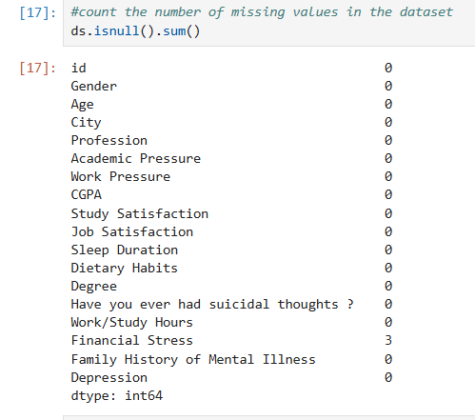

Q17. Fill missing values with zero

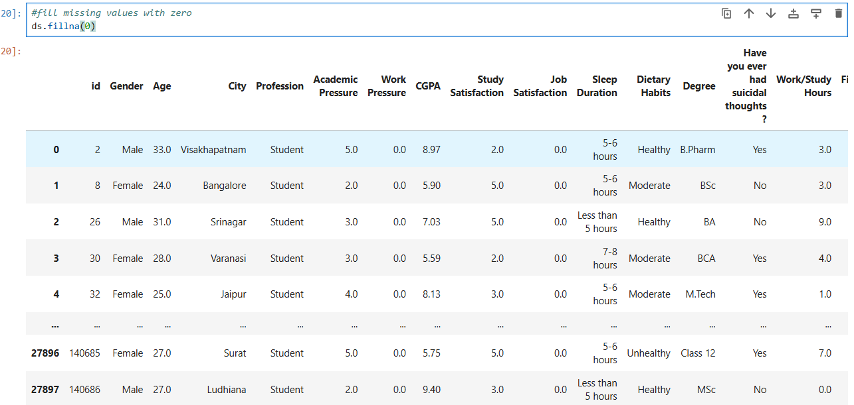

Q18. How to count missing values per column?

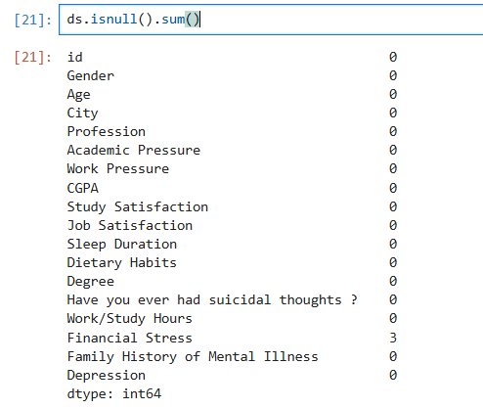

Q19. check the datatypes of the column

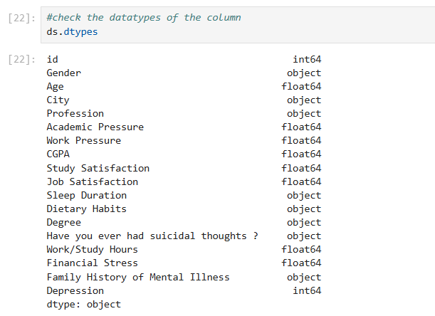

Q20. Sort the dataset or dataframe based on specific column

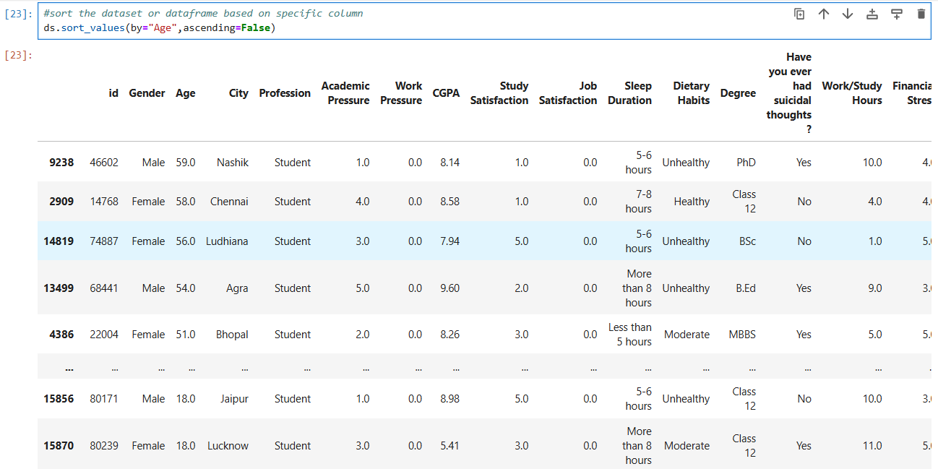

Q21. How to sort a pandas DataFrame by the column (“Age”)?

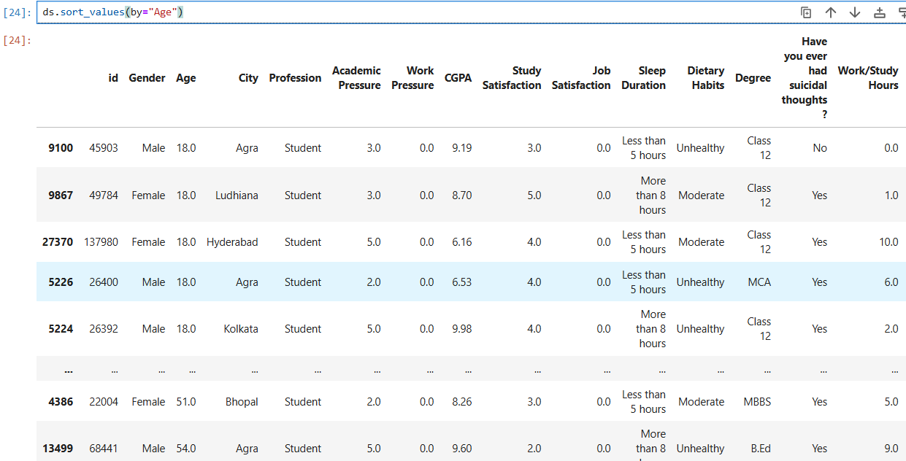

Q22. How to sort by "Age" and show the top 10 rows in pandas?

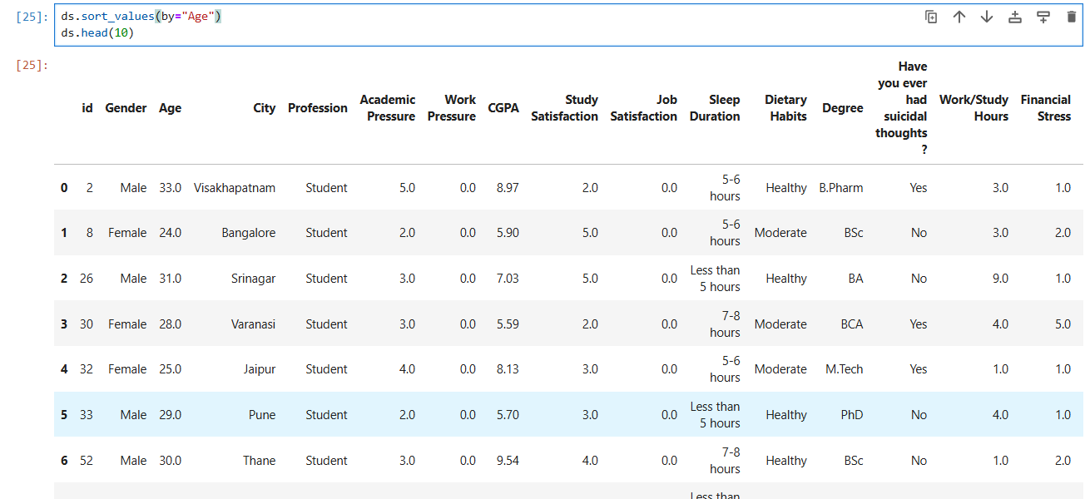

Q23. find minimum and maximum value of column

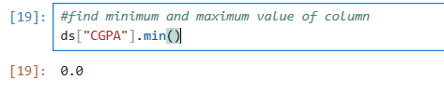

Q24. Find maximum value of the column

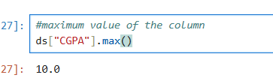

Q25. Unique values in the column

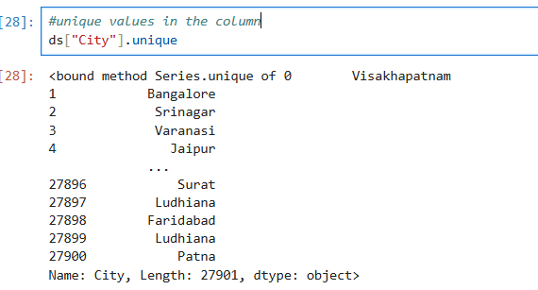

Q26. no of unique valus in the column

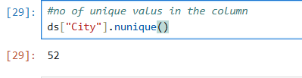

Q27. filter the rows where the person has suisidel thoughts

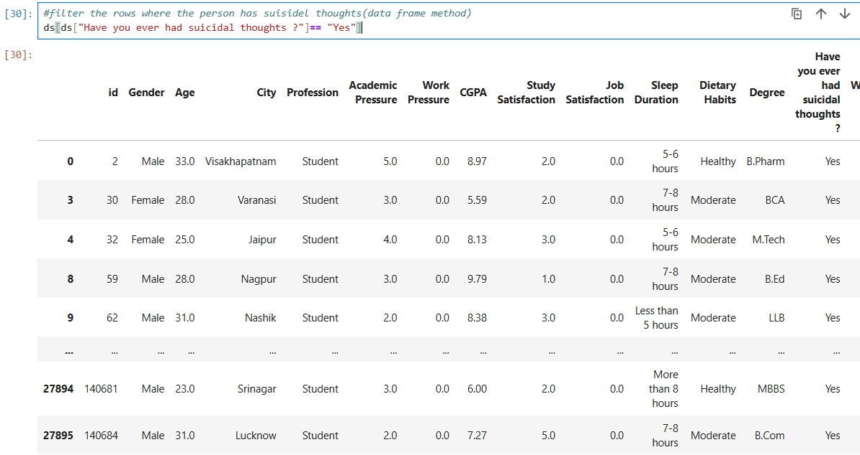

Q28. filter for high financial stress

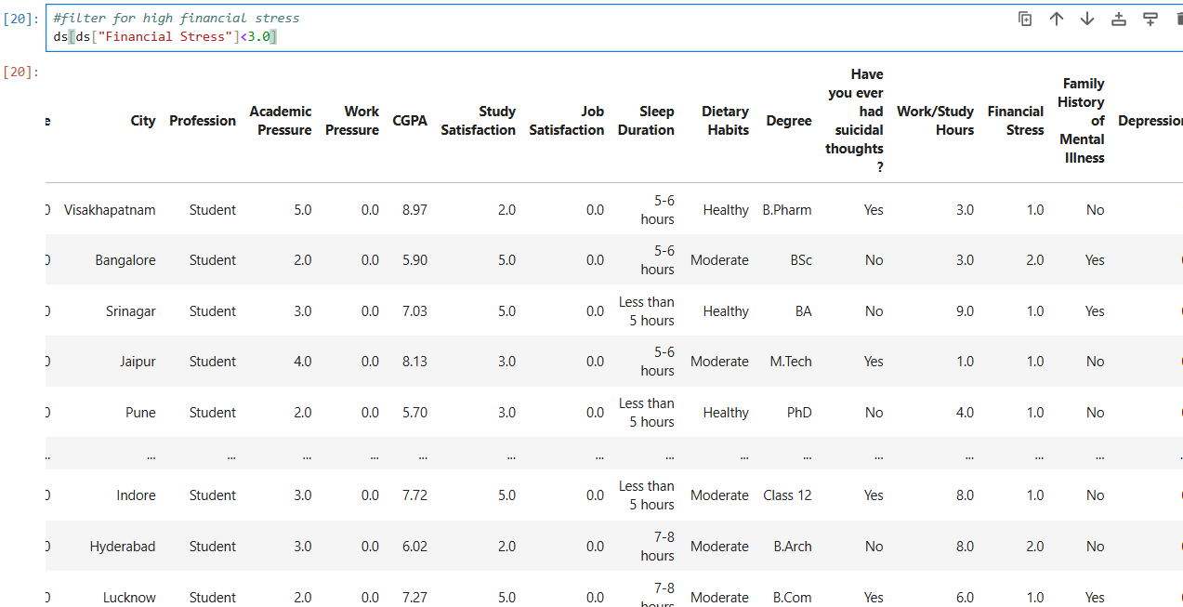

Q29. change he value of column

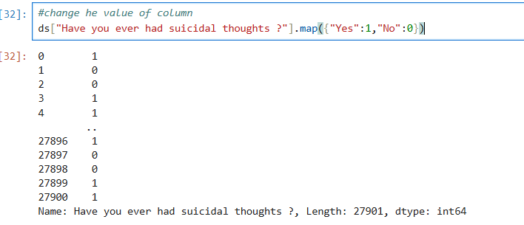

Q30. select the element in the first row and first column

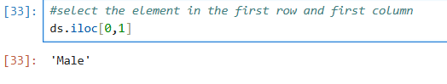

Q31. selects the element in the first row and first column of the DataFrame

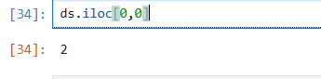

Q32. find all rows where gender is female and depression is one

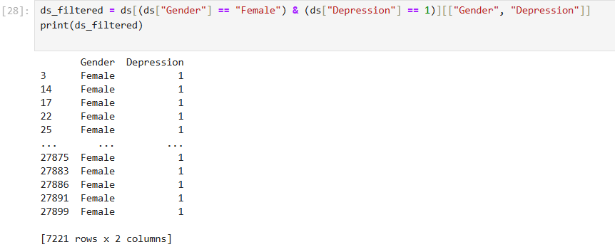

Q33. Select the first thre rows of the age and cgpa column

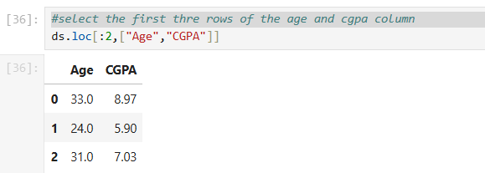

Q34. change the sleep duration for he person with id=1 to 8 to 9 hour

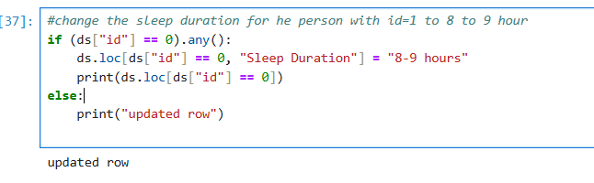

Q35. print the first and fifth row along with second column

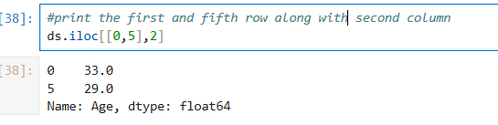

Q36. How to get the "Degree" column for rows 0 and 5

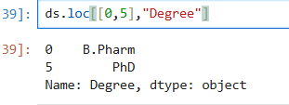

Q37. How to count the occurrences of each unique city in the "City" column?

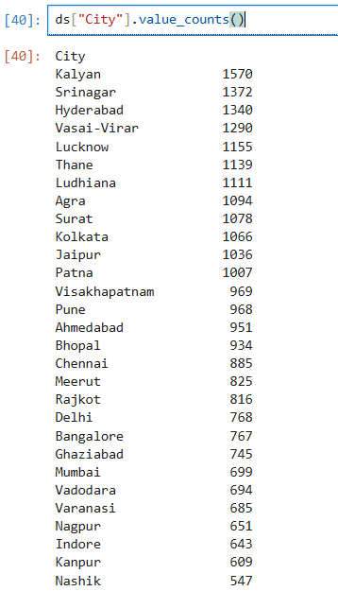

Q38. select two column named degree and sleep duration start from index no1 and end on index no18 and skip at 2

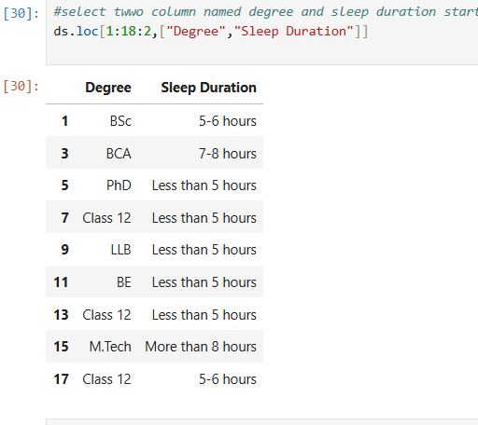

Q39. Range of column

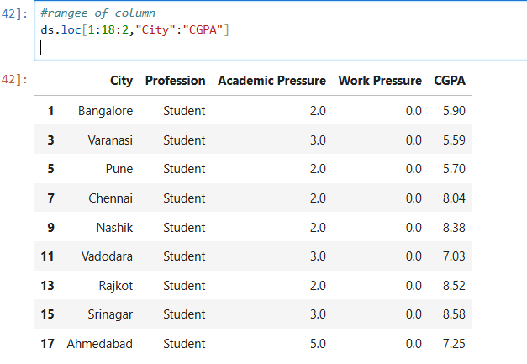

Q40. write a code to filter a dataframe or dataset and select rows where the city column is kalyan, jaipur or delhi and then select only financial stress column from the filtered rows.

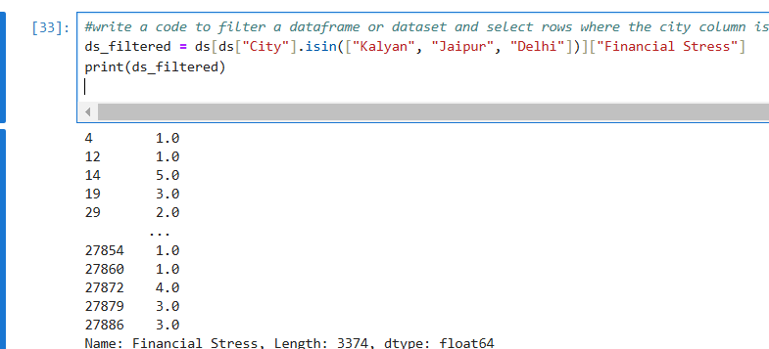

**TOPIC: FAKER DOCUMENTATION**

Q1. Importing all the file to create a Data.

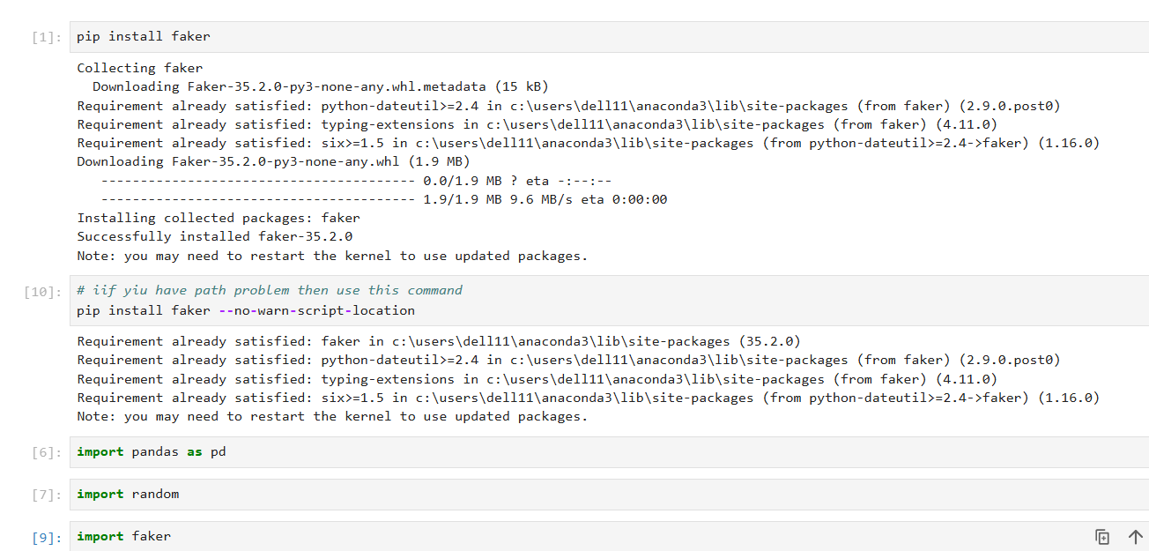

Q2. Generate a Data Frame using Faker for "Email ID", random for "Age".

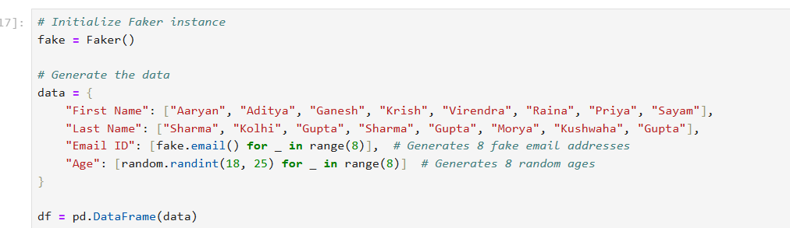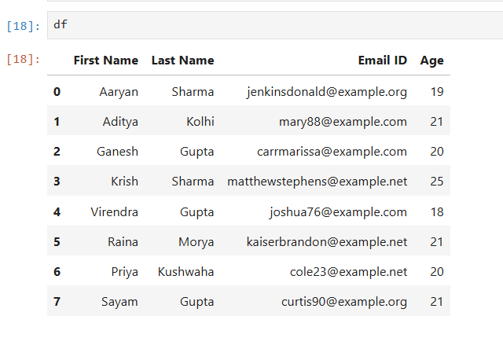

Q3. Creating a Fake Data.

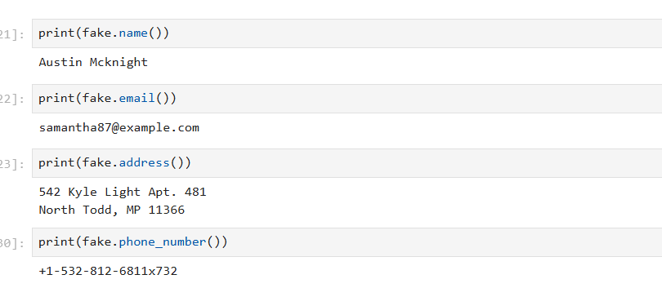

Q4. Create a Data Frame with 10 records using Faker to generate "Name", "Address", "Email", "Date of Birth", "Phone Number", and "Company".

Q5. Generate a fake Indian name using Faker('en_IN').

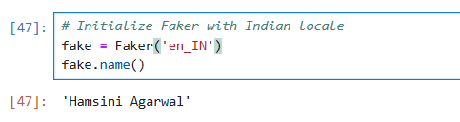

Q6. Save the DataFrame as a CSV file without the index and display it.

Q7. Display all the Columns of Table



Q8. Rename the index 0 ‘name’ to ‘full name’

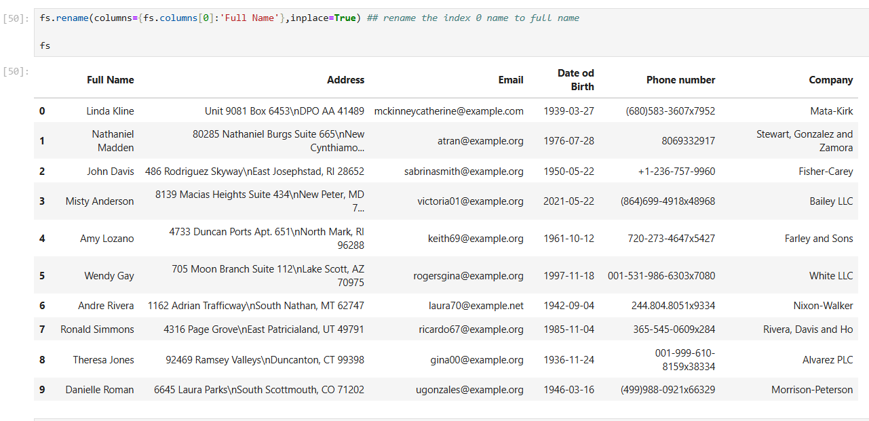

Q9. Rename the "Phone number" column to "Contact" and "Email" to "Email Address" in the DataFrame.

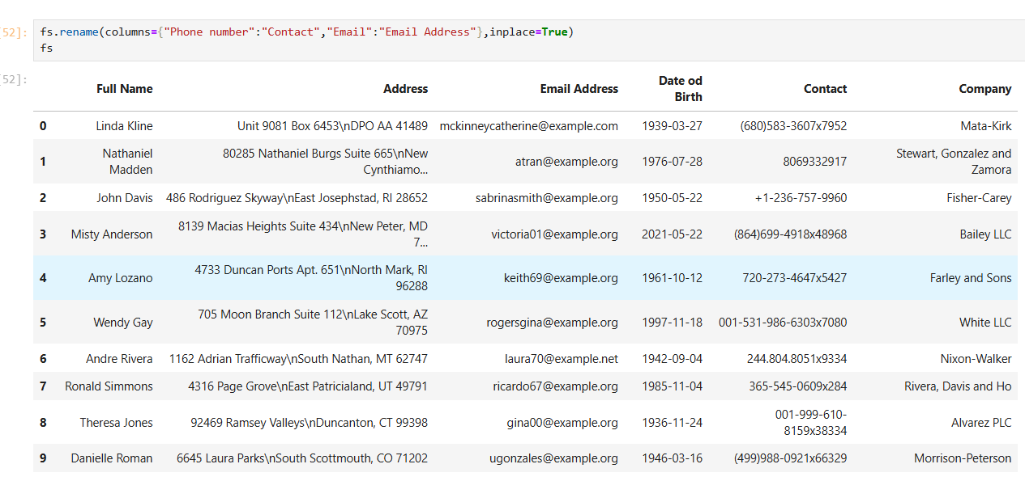

Q10. Show all the columns name in Lower Case.

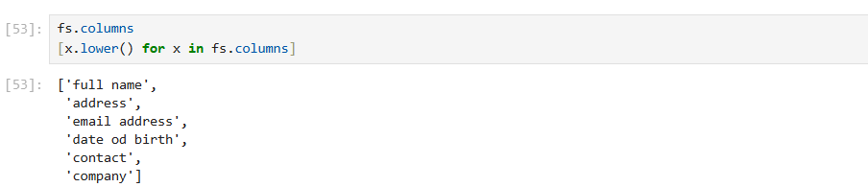

Q11. Show all the columns name in Upper Case.

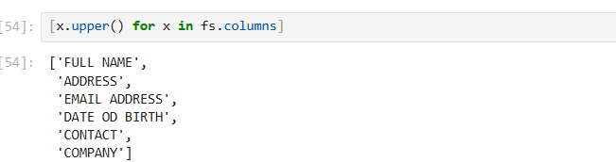

Q12. Replace empty spaces in column names with underscores in the DataFrame.

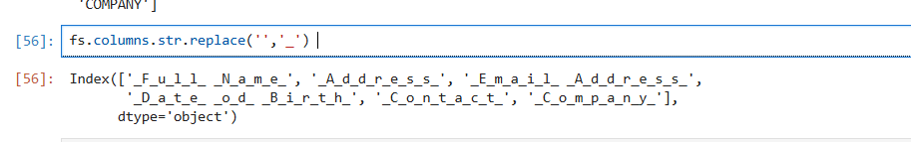

Q13. Update the 3rd row (index 2) of the DataFrame with new values for "Name", "Address", "Email", "Date of Birth", "Contact", and "Company".

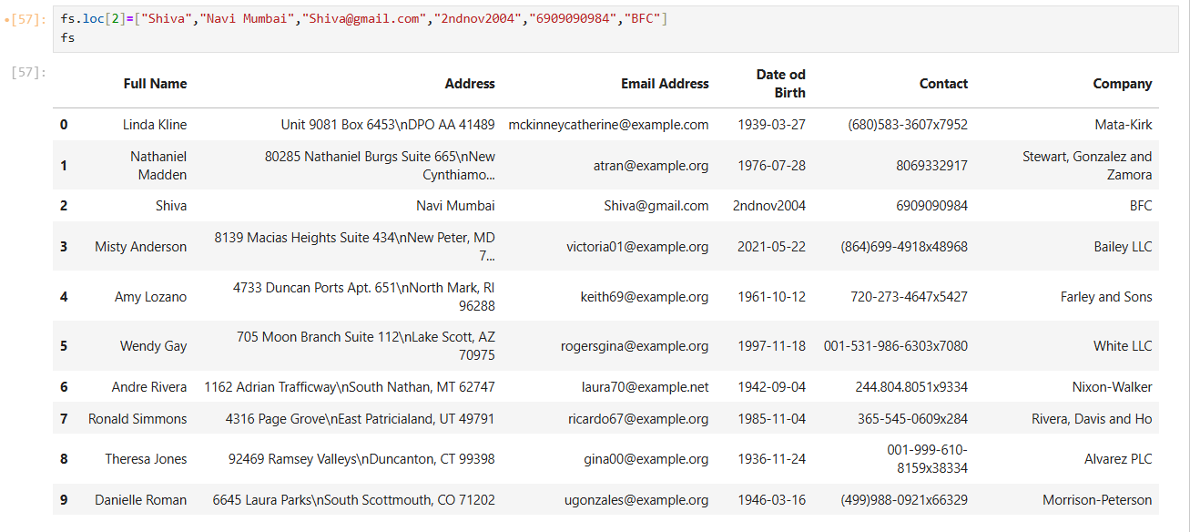

Q14. Change the 5th row's "Address" to "UP" and show the DataFrame.

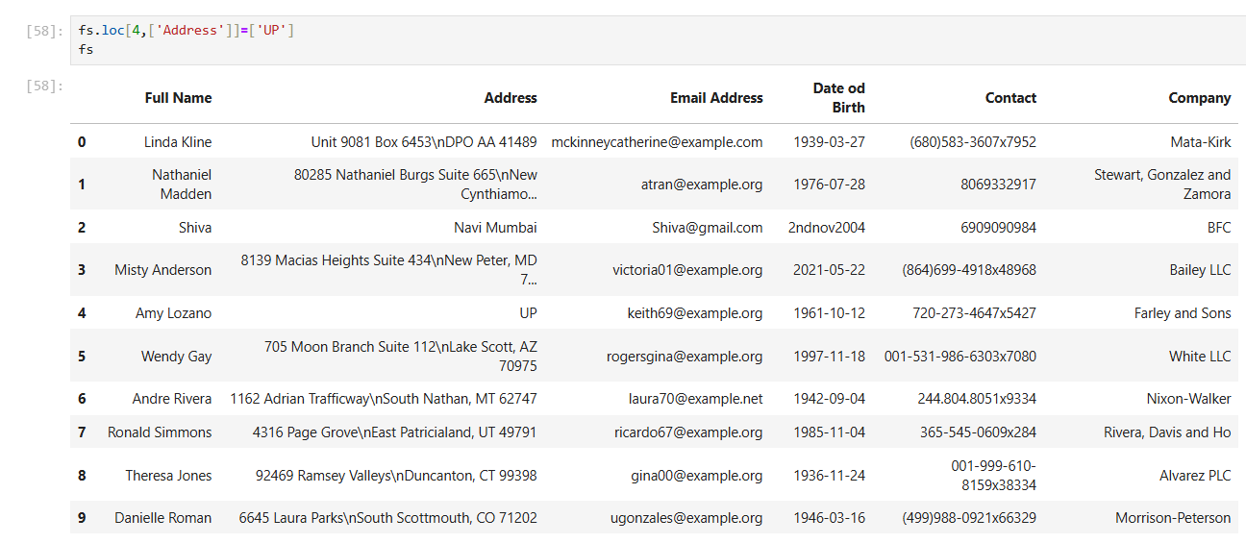

Q15. Find the length of each email in the DataFrame.

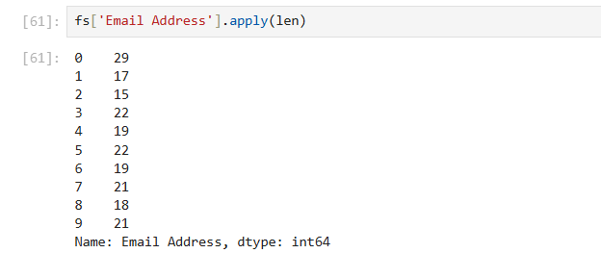

Q16. Find the total number of entries in the "Email Address" column.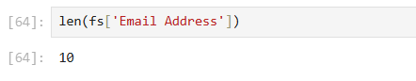

Q17. Find the number of elements in each row of the DataFrame.

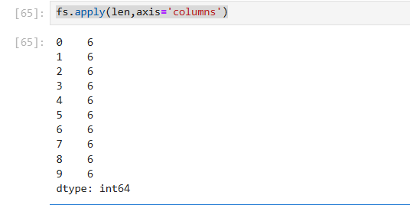

Q18. Define a function that converts an email to uppercase.

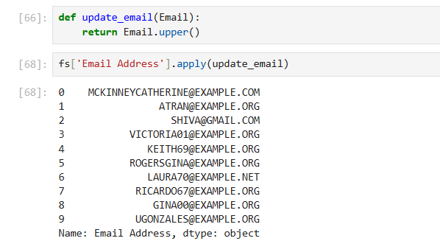

Q19. Define a function that converts an email to lowercase.

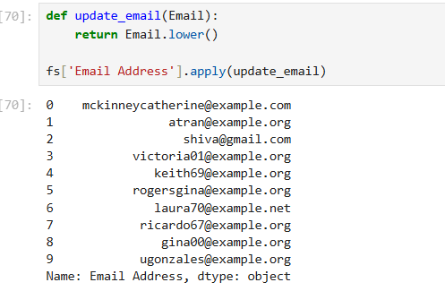

Q20. Convert all emails in the "Email Address" column to uppercase without using a function and display the DataFrame.

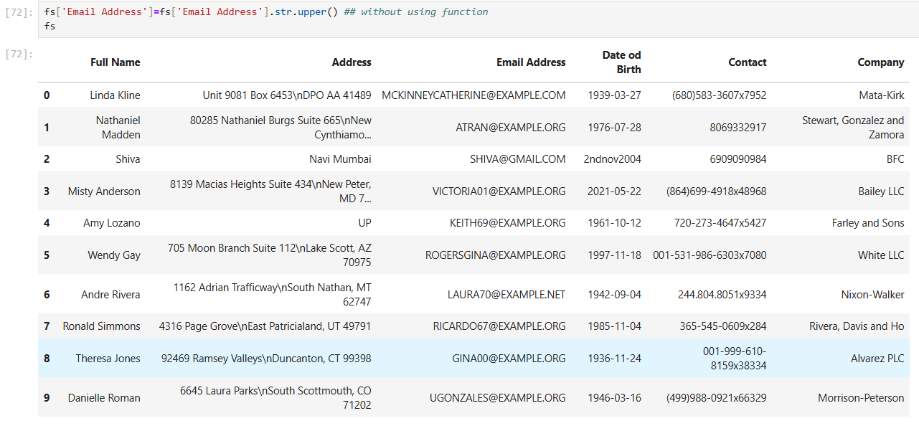

Q21. Convert all emails in the "Email Address" column to lowercase using a lambda function and display the DataFrame.

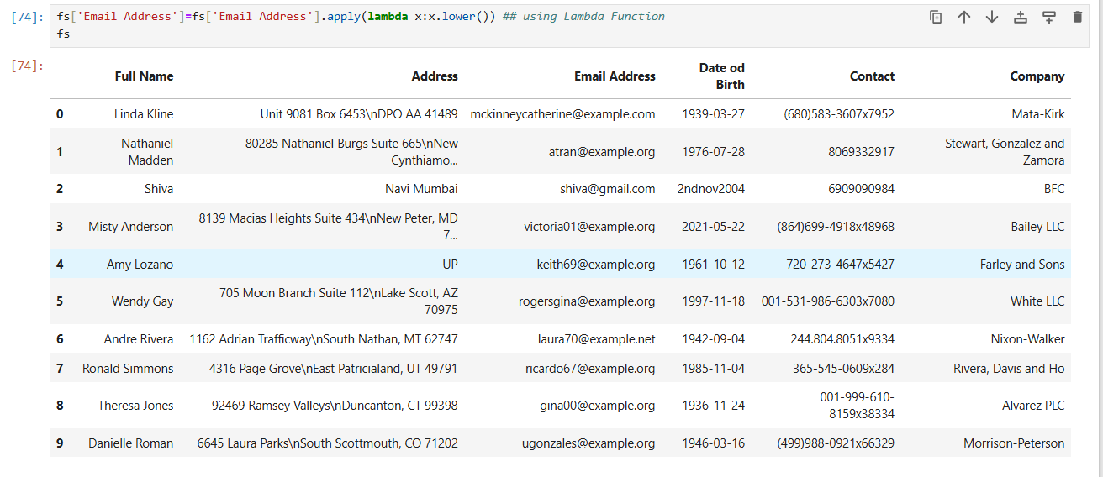Q22. Find the length of each value in the "Full Name" and "Company" columns using applymap().

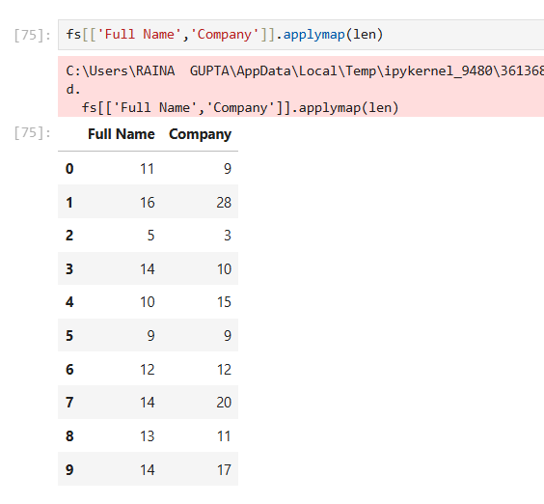

Q23. Create a new column by combining "Full Name" and "Email Address".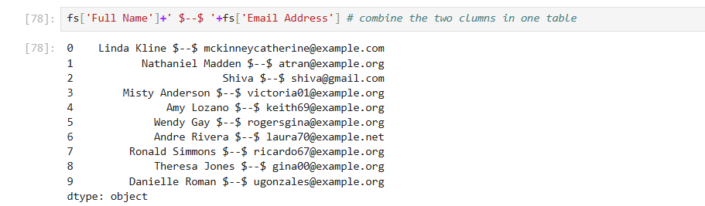

Q24. Create a new column "Detail" by combining "Full Name" and "Contact", then display the DataFrame.

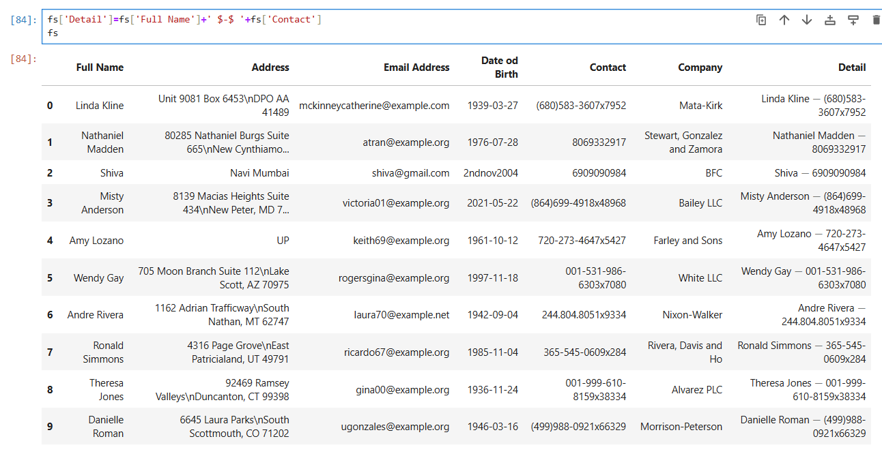Q25. Drop the column name Detail

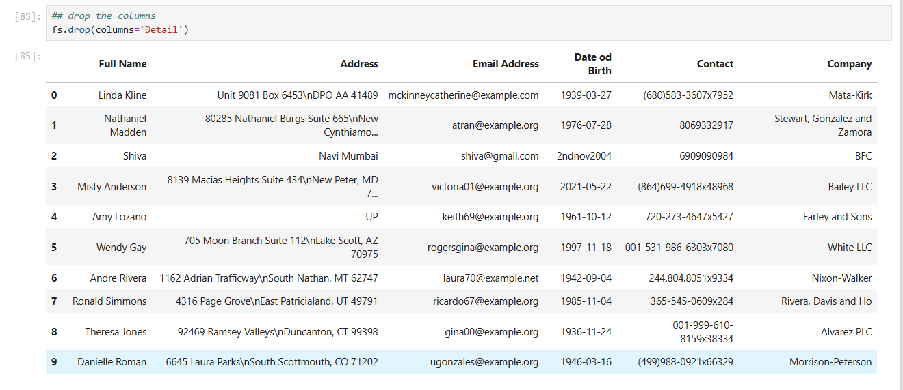

Q26. Split the "Detail" column by an empty string ('') and expand the result into multiple columns.

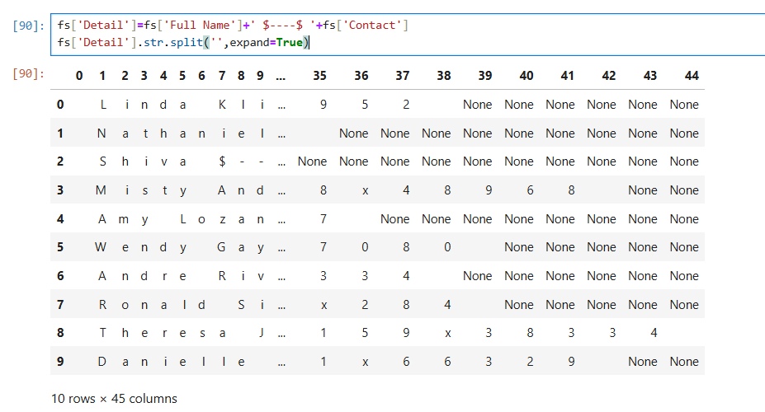

**TOPIC: Graph**

Q1. Import pandas for data manipulation and matplotlib.pyplot for plotting.



Q2. Plot a line graph and display it.

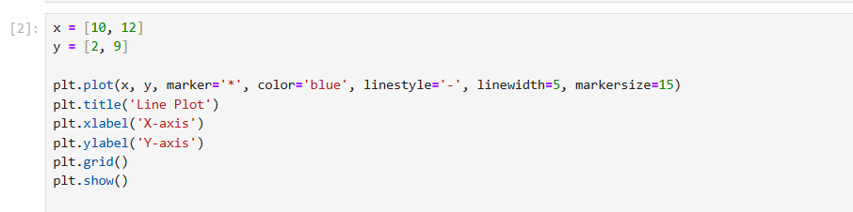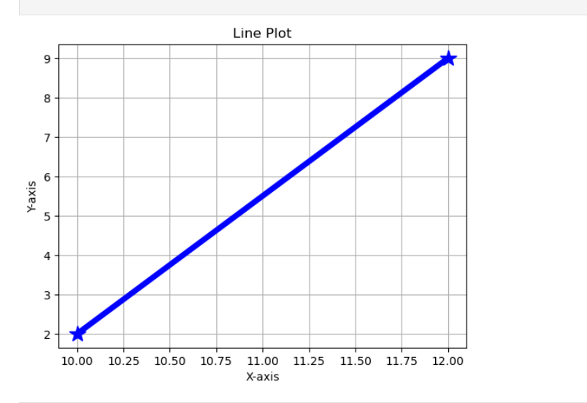

Q3. Create a scatter plot and display it.

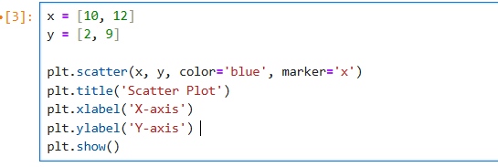

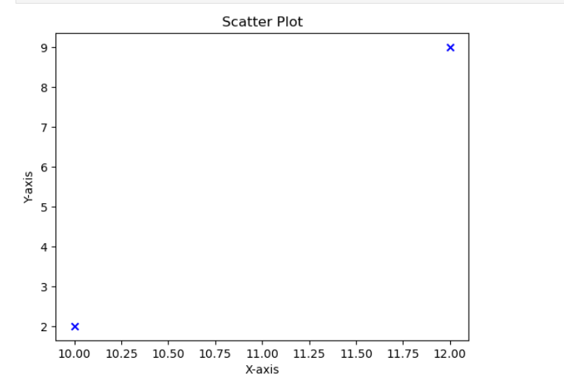Q4. Create a bar plot for Name and age then display it.

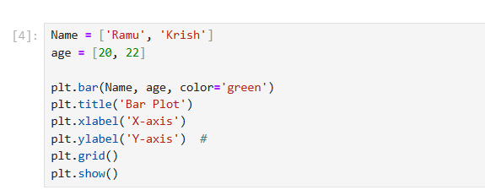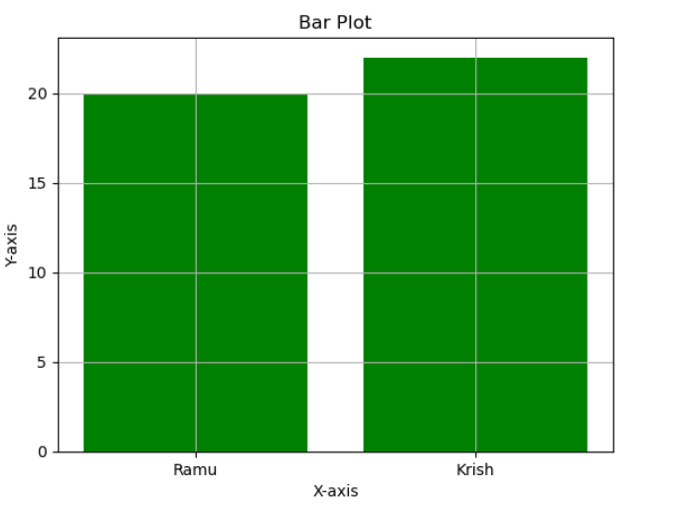

Q5. Create a red histogram with black edges and display it.

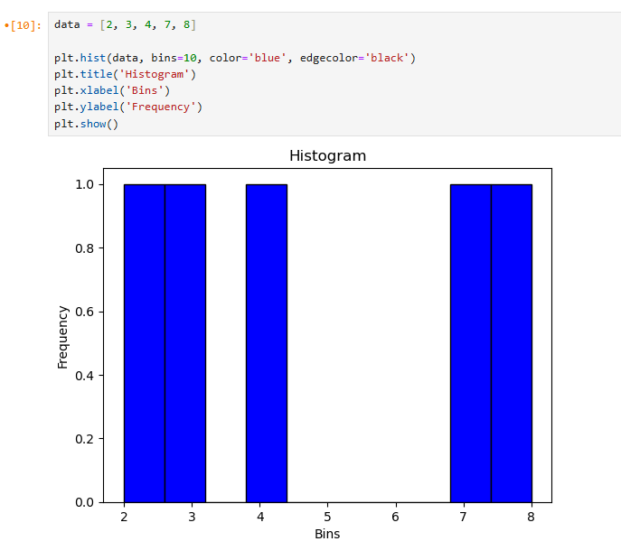

Q6. Create a pie chart for sizes with labels showing percentages and a title.

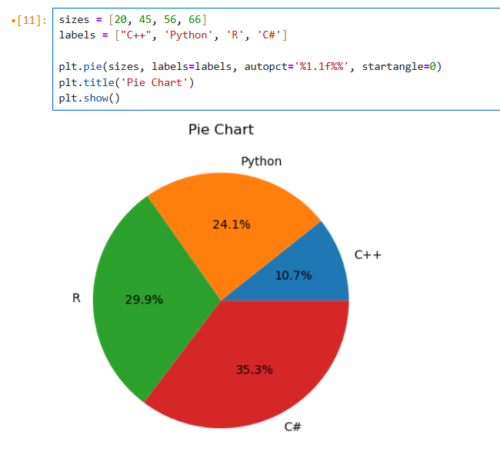

**TOPIC: DATAFRAME**

Q1.How do you import the pandas library in Python?



Q2. How do you create a dictionary for Indian student data with 'Name', 'Age', 'Grade', and 'City'?

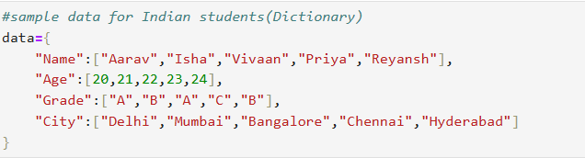

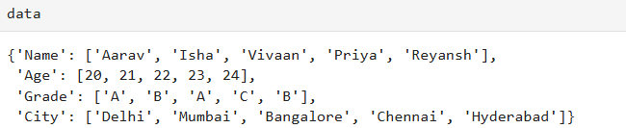

Q3. How do you create a DataFrame dt from the given dictionary data?

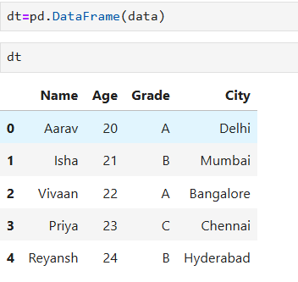

Q4. How do you create separate lists for 'names', 'ages', 'grades', and 'cities' in Python?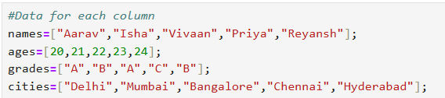

Q5. How do you create a DataFrame dt using zip() to combine lists in Python?

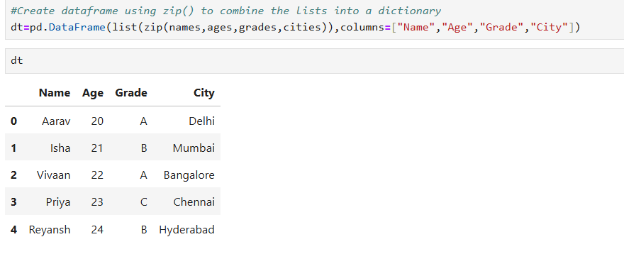

Q6. How do you use numpy to perform calculations on numerical data in Python?

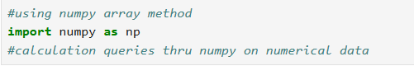

Q7. How do you create numpy arrays for 'names', 'ages', 'grades', and 'cities' in Python?

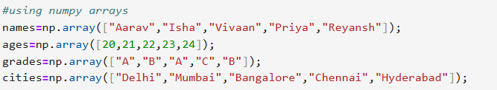

Q8. How do you create a DataFrame df using numpy arrays for 'Name', 'Age', 'Grade', and 'City'?

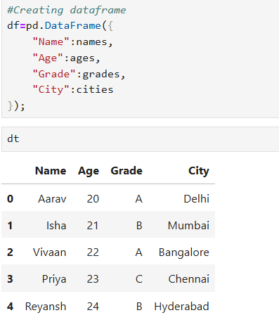

Q9. How do you create a dictionary data containing lists for 'Name', 'Age', 'Grade', and 'City'?

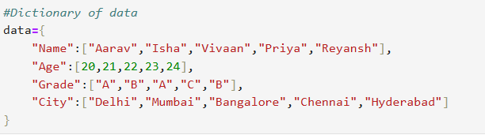

Q10. How do you create a DataFrame dt from a dictionary data using from_dict()?

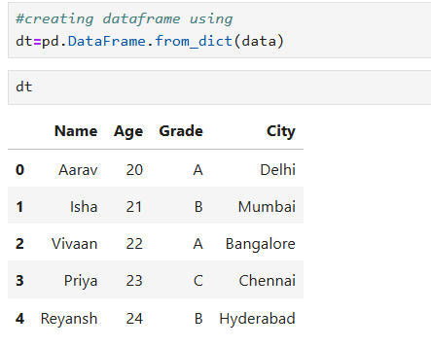

Q11. How do you create a list of dictionaries for 'Name', 'Age', 'Grade', and 'City'?

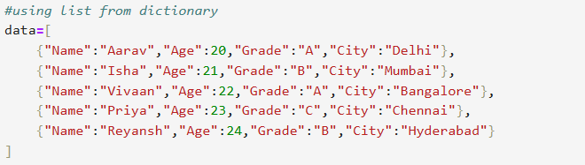

Q12. How do you create a DataFrame dt from a list of dictionaries in Python?

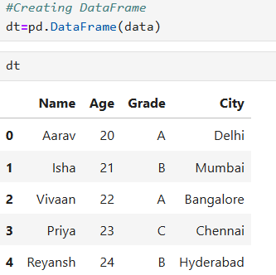

Q13.Write the df.shape?

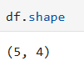

Q14.Write the rows and columns?

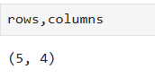

Q15.Write the rows?



Q16.Write the columns?

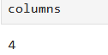

Q17. How to get 'Name' and 'Age' for rows where 'Grade' is 'A'?

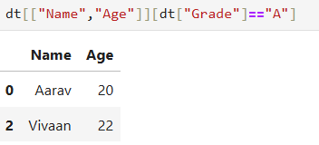

Q18. How to set the index of a DataFrame to the 'Name' column?



Q19. How to reset the index of a DataFrame and set 'Name' as a column again?

